***The Friends of Beccles Library present***

# ***The Future of Artificial Intelligence***

# ***with Ben Taylor***

***Friday 4th August @ 7.00pm***

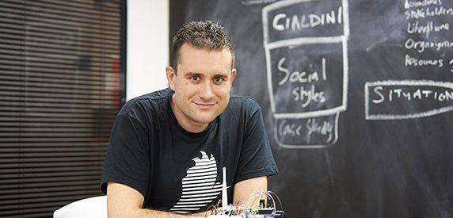  
  
The talk will be delivered by CEO of Rainbird, computer scientist and expert in his field, Ben Taylor.  
"Rainbird is an artificial intelligence platform that can model human-like cognitive reasoning processes, and deploy them at scale."

He has recently served as government scientific adviser, to specifically address the some of the issues in this talk.  
Doors open 7:00pm  
Wine and nibbles served  
Talk commence 7:15 - 30 mins.  
Brief break.  
Questions from the floor

Tickets £3 - to help raise funds for Beccles Library